GRANT BURGE

2016 HILLCOT MERLOT

The Fruit
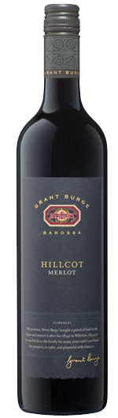
Grant Burge was a pioneer of Merlot in the Barossa Valley and planted the first Barossa Merlot vineyard in the Hillcot Vineyard in 1982. When our first straight Merlot was produced, there were only two others available in Australia, and although there are more straight Merlots being produced now, Grant Burge Hillcot Merlot sits among the top-selling Merlots in its price bracket.
The 2016 vintage in the Barossa saw a cool winter with lower than average rainfall, which continued into spring, with warmer than average temperatures through November, December and January. Late January rain combined with a mild February and March allowed for a smooth harvest and good flavour development. The 2016 vintage is regarded as a very good to exceptional year for reds in the Barossa.

The Winemaking
The fruit was crushed into static fermenters and left on skins to extract the colour and flavour of the fruit. The wine was fermented at between 24 and 28°C to retain delicate fruit characters. The wine was matured in a combination of French and American oak for 15 months before being bottled.

The Wine
The 2016 Hillcot Merlot is deep red in colour with purple hues. The nose is dominated by rich aromas of blackberry, cherry, mint, dark chocolate, mocha and sage. The soft, supple palate has concentrated flavours of red berries, with soft ripe tannins that add balance to the oak and fruit sweetness. A generous, refined fruit structure, this medium-bodied wine is ready to enjoy now or can be cellared for seven to 12 years.

